**Review version**

Do not cite or circulate

Ex ante impacts of spatially differentiated agronomic recommendations for wheat farmers in Eastern India

Maxwell Mkondiwa, Jordan Chamberlin, Andrew McDonald, Anton Urfels

# Abstract

We introduce the concept of “personalized agronomy,” adapted from “personalized medicine,” as a computational modelling framework for policy decision making on where and to whom agronomic innovations should be targeted for maximum agronomic and economic returns across a given target population. We rely on a doubly robust machine learning model and policy learning approach to generate individualized recommendations for farmers in a large survey sample, and then illustrate how such estimates can be used to generate tailored recommendations for new farmers in the target geography using out-of-sample policy evaluation. We illustrate this computational modelling framework using a case study of wheat farmers in Bihar and Eastern Uttar Pradesh States, India. The recommended practices include broad-spectrum herbicides, early sowing, repeated irrigation, and using high-yielding long-duration varieties. This work demonstrates how field and farmer heterogeneity can be incorporated into a spatially explicit analytical framework for improved targeting of extension efforts and improved aggregate efficiency of related public and private investments.

# 1. Introduction

Evaluations of agricultural research and development (R&D) interventions have documented very high returns with global average benefit-cost ratio of 10:1, ranging from less than 2:1 to 42:1 (Alston et al 2020). However, the distribution of returns at the farm and community level is highly heterogenous, reflecting both variations in production conditions as well as management practices and other farm-level characteristics (Suri 2011; Suri and Udry 2021). This heterogeneity in returns has prompted many researchers to recommend prioritization and targeting of interventions as key to unlocking the gains from agricultural R&D. However, the best methods for targeting remain uncertain especially due to the complexity in making causal judgements and predicting potential performance of the recommended practices out of sample.

We propose that personalized agricultural recommendations (personalized agronomy) are possible using novel machine learning and operations research tools that have proven successful in personalized medicine (see Inoue et al 2023) including in transporting clinical trial results to a new target population (Dahabreh et al 2020). In this paper, we use an *exante[[1]](#footnote-1)* approach of personalizing agricultural recommendations to each farmer and farm context using causal machine learning (Athey et al 2019) and targeting of farmers on the basis of their farm and personal characteristics using policy learning (Athey et al 2021). We demonstrate the framework using several crop management practices in wheat in Eastern India (Bihar and Eastern districts of Uttar Pradesh). These crop management practices include: weed management, irrigation management, varietal choice and sowing date schedule. By considering multiple crop management practices, we explore the different targeting metrics needed for each practice.

Additionally, the potential benefits of crop management practices are conditional on farmer characteristics and therefore there is a need to match solution spaces to underlying agroecological heterogeneity (Snapp et al., 2022, McDonald et al, in review). This has been well documented for many crop management practices. In India for example, Krishna et al (2020) documents that zero tillage has high returns but mostly to larger farms therefore requires proper targeting. Other research in India suggests that returns from technology can be doubled if guided by remotely-sensed information (Jain et al., 2019). This heterogeneity can be well studied in a new framework of “personalized agronomy” borrowing on “personalized medicine”—a data-driven approach to making personalized recommendation on agronomic management.

Machine learning algorithms have gained prominence in achieving the goal of generating site and context specific recommendations. Data-driven decision support tools in agriculture are increasingly based on data-based geographical zonation using non-parametric approaches like random forest algorithms, classification and regressions trees (CART), and cluster analyses (e.g., Krupnik et al 2015, Urfels et al 2021) rather than traditional statistical approaches (e.g., analysis of variance). This approach however does not provide explanations for the individual specific responses and does not have a clear path to prescribing what the farmers in each cluster need to do to increase yields. In addition, this line of research still does not recommend who should receive the intervention and the welfare criteria for such decisions (i.e., individual level variation of recommendations within geographical recommendation zones). Other studies (e.g., Jones et al 2022) have used interpretable machine learning tools like Shapley additive explanation (SHAP) . The main limitation of these prediction focused machine learning approaches is that they do not capture the causal effects of the interventions especially in agricultural applications where farmer choices of the practice may be correlated with several factors affecting yields thereby biasing the response effects. For personalized recommendation development, causal estimates of the yield response to the technology matter more yet a good prediction accuracy does not translate to good prediction of the yield response (Tanaka et al 2024, Kakimoto et al 2022).

To address this challenge, we use a targeting approach based on causal machine learning to define intervention assignment rules based on both farm and farmer characteristics while weighting the estimates on the propability of the farmer to adopt each of the practices as predicted using observable characteristics. We use a casual random forest model, which provides a flexible framework for estimating heterogeneous treatment effects and which performs well at generating out-of-sample yield response predictions to inputs (Athey et al 2019, Credit and Lehnert 2023).

We combine this approach with the policy tree algorithm (Athey et al 2021) to suggest who would likely benefit from targeted recommendations on agronomic practices. The combined causal random forest and policy tree optimization approach is different from the prediction oriented machine learning approach of using random forest. A succinct comparison is provided by Wager and Athey (2018) and Kakimoto et al (2022) who reviewed the theoretical differences between causal random forest and random forest estimators. The main difference is that in random forest, the sample is split to minimize mean squared error of yield predictions while in causal random forest splits the sample to minimize the mean squared error of the treatment effects by using honest trees (Kakimoto et al 2022). For treatment assigment, policy trees are also different from CART in several ways. First, CART selects the partition by adding recursive sample splits to the tree without anticipating later splits while policy trees search for a fixed tree depth over all possible targeting policies (Cagala et al 2021). Second, policy trees allow one to include constraints including budgetary limits and fairness.

We contribute to two strands of literature. The first is on applications of causal machine learning in crop management decisions (McCullough et al 2022, Kakimoto et al 2022, Giannarakis et al 2022, Deines et al 2022, Quigley et al 2023, Klueger et al 2022, Cambron et al 2024, Stetter et al 2022, Mulungu et al 2023). McCullough et al (2022) compared estimates from random forest and causal random forest on the nitrogen effect on maize yields in sub-Saharan Africa. They found that the predicted fertilizer response with a causal random forest model (1.49) was higher than that for a random forest model (1.26) but lower than that of a feasible generalized least squares estimator (2.07). In terms of prediction which could be done by comparing a random forest estimator and generalized least squares estimator, they found that the random forest predicted better with a small root mean squared error (RMSE). Kakimoto et al (2022) discusses the differences between prediction-oriented machine learning methods (e.g., random forest, convolutional neural networks) and causal random forest in an agronomy related simulated data of N optimal management. They found that causal random forests are advantageous because of a lower mean squared error (MSE) for predicting crop responses in Monte Carlo experiments as compared to the prediction based machine learning approaches (e.g., random forest, and convolutional neural networks). This is because causal random forest estimator relies on honest trees which are constructed to minimize MSE for heterogeneous treatment effects while random forest relies on sample splitting to minimize MSE for yield outcome prediction. We depart from Kakimoto et al (2022) on the optimization framework in that instead of using individual comparison of the different categories, we instead using policy tree algorithm (Zhou et al 2022) which also specifies which variables would efficiently allocate farmers to the different categories.

While the agricultural related applications cited above used a binary classification of the treatment variable, we consider applications in which the treatment variable is a categorical variable. This allows us to provide transition pathways across the different categories of technologies. For example, whether it is best for farmers to first switch from no weeding to manual weeding or that they can simply switch to herbicide weed management options. Unlike many of the agricultural related applications that considered only biophysical variables, we include several controls including other management variables, and socioeconomic variables (e.g., education, caste).

The second strand of literature is on exante spatial priorization frameworks that rely on credible causal evidence, costs of implementation, and leveraging on spatial dependence and clustering for efficient targeting (Giannarakis et al 2022, Cameron-Harp et al 2024, McCullough et al 2022). The applications of causal random forest modelling for targeting recommendations have mostly relied on using gridded data and bivariate mapping to prioritise locations with unfulfilled adoption levels but high exante yield gain potential due to the technology (e.g., Cameron-Harp et al 2024). This approach provides a simple approach for targeting locations by prioritizing areas with high yield potential and high unfulfilled adoption potential. For studies that are based on point data like McCullough et al (2022), they have relied on predicting the responses to an appropriate grid for the area of interest by masking crop production areas. This approach can be considered as full targeting in that one is using all variables in the targeting procedure. It is however almost impossible to implement in practice because of the cost of conducting the surveys needed to assign farmers into the different crop production practices.

Another more comprehensive approach proposed by Athey et al (2021) approximates the full targeting procedure and allows the use of a limited set of observable and easy to collect variables. This approach is gaining prominence especially for out-of-sample predictions and adaptive experimentation. For example, Athey et al (2023) has) has piloted the use of causal machine learning based recommender systems and have found them to be better than conventional approaches.

Using this causal random forest and policy tree optimization approach, we find that the recommended practices include broad-spectrum herbicides, early sowing, repeated irrigation, and using high-yielding long-duration varieties (HD 2967 and Shriram Super 303). In terms of the yield gains as compared to the status quo, we find that using mixture herbicide like Sulfusulfuron+Metsulfuron provides the highest yield gains followed by 2,4-D, manual plus herbicides, and lastly manual. This applies both in terms of the average returns as well as for each individual farmer. Spatially, there is substantial variation which provides a simple targeting rule that policy makers can use—focus on the areas where there are high potential yield gains and high adoption gap.

The policy tree targeting procedure which approximates the full targeting using a few variables provides very high welfare gains across all the crop management practices especially to those who those using traditional crop management practices (e.g., not weeding, sowing late, applying less than or equal to two irrigations, and using short duration wheat varieties). For each of these categories of farmers, the targeted policy substantially allows them to get higher yields.

For the case of the superior practices however, the targeted policy does not effectively improve the welfare of the median farmer if they had instead used the best uniform practice for the entire area of interest (e.g., apply S&M herbicide, sowing in 1-10 Nov, irrigation at least four times, and planting long duration varieties). For farmers who are already doing these interventions, the targeted policy shifts some of them to the other better alternative leading to a welfare loss. These findings are consistent with prior studies that observed that in datasets in which there is a clearly beneficial intervention across all sites, the policy tree approach assigns few of the observations to the less superior treatment (Athey et al 2024b).

The rest of the paper is organized as follows. We present next the methods section (section 2) detailing the data and empirical strategy. We then present the results in section 3 following by a discussion section 4. We finally conclude in section 5.

# 2. Methods

## 2.1. Data

We use three main data sources: the Landscape Diagnostic Survey (LDS) data for wheat, *geodata* R package and Climate Hazards Group InfraRed Precipitation with Station data (CHIRPS). The landscape diagnostic survey is a landscape level crop assessment survey covering about 8000 households administered in 2017-18 in Bihar and Eastern Uttar Pradesh by the Cereal Systems Initiative for South Asia (CSISA).

Figure 1 shows the count of farmers who use weed management and irrigation options[[2]](#footnote-2). Figure 1a shows the count of farmers using different weed management options while figure 1b shows the corresponding yields for farmers using these options. A substantial number of farmers do not weed at all resulting in very low yields. Sulfosulfuron+Metsulfuron (S&M) has the highest unconditional yield followed by manual plus herbicide, and 2,4-D.

Figure 1c shows count of farmers by the number of irrigations they apply. Most farmers irrigate two times, despite substantial yields they would get if they had increased the number of irrigations (figure 1d).

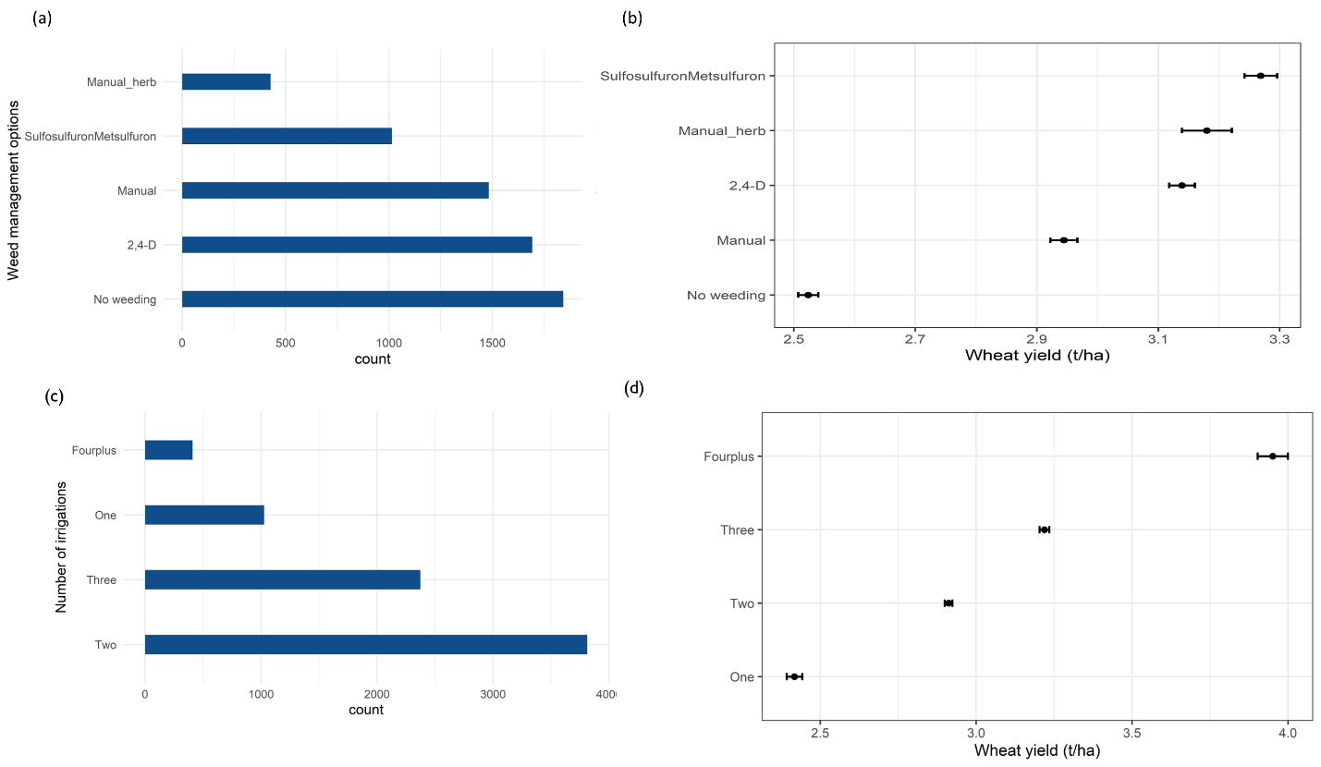

Figure 1: Frequency of farmers and yields by agronomic practices followed.

Note: Panel a and c show the number of farmers adopting each of the practices while panel b and d show the average and confidence interval of wheat yields by the agronomic practices.

Figure 2 shows the count and mean yield distribution bysowing date and varietal options. The sowing date comparisons are clear with sowing in 1-10 Nov window giving the highest yields (figure 2b) yet the majority of farmers sow in 21-30 Nov (figure 2a). For varieties, the higher yielders include HD 2967, HD 2733 and SUPER 303 (figure 2d).

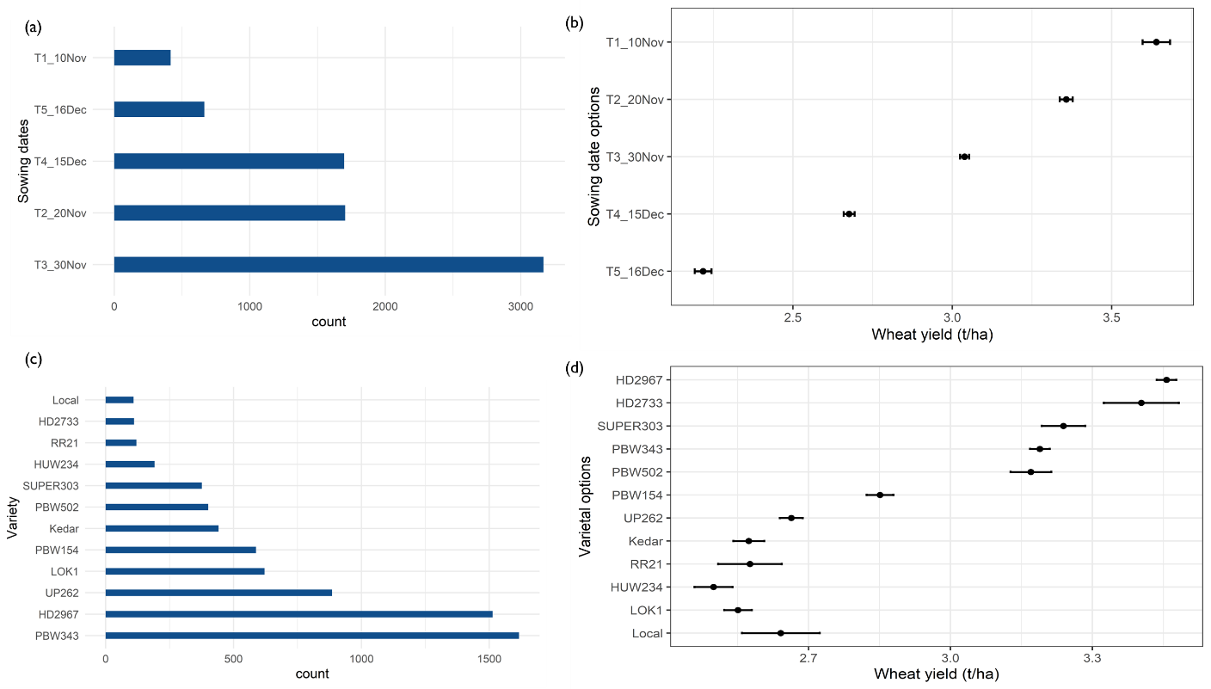

Figure 2: Frequency of farmers and mean yield comparisons across agronomic practices. Note: Panel a and c show the number of farmers adopting each of the practices while panel b and d show the average and confidence interval of wheat yields by the agronomic practices.

The rest of the variables are summarised in appendix table A1.

## 2.2. Empirical strategy

We use a four step analytical process (figure 3) beginning with, (1) estimating a probability random forest model followed by a causal random forest model that uses the predicted probabilities from the first random forest as weights, (2) predicting individualized treatment effects, (3) estimating doubly robust scores, and (4) applying policy tree algorithm that include agronomic variables (e.g., irrigation applied, soil quality) and socio-economic variables (e.g., education) to optimally recommend a policy that can be targeted to each farmer. This procedure follows the policy tree algorithm by Zhou et al (2022) and Athey and Wager (2021). Following Athey and Wager (2021), a policy () is a rule or method by which we decide, who, on the basis of their characteristics will be targeted to receive intervention:

Where are characteristics of the farmers including their demographics, farm characteristics and plot characteristics. indicates the interventions to be targeted. It can be a dichotomous decision (e.g., plant early or late) or a discrete decision (e.g., weekly planting schedules). In most agronomic evaluation, the value of the agronomic practice is represented in form of yield gains which can be defined as a conditional average treatment effect (CATE):

Where is expectation term. is the yield (it can also be revenue or profits) with being yield with agronomic practice while is the control.

### 2.2.1. Causal random forest conditional average treatment effects (CATE)

We start from step 1 and 2 in the workflow (figure 3) in which we estimate a yield crop response model using causal random forest model with augmented inverse weighted propensity score (AIWP).

Unlike random forest models, causal random forests use honest splitting in which splitting is done on training sample and uses independent sample to estimate leaf means. Causal random forests also allow orthogonalization for observational (survey) data using Inverse-Probability Weights predicted from probit model. Augmented Inverse-Probability Weighted Conditional Average Treatment Effect (AIPW-CATE) is given by

Where are treatment assignment probabilities. In all the specifications, we control for all confounders including variety type, date of sowing, fertilizer applied, soil quality variables (including soil nitrogen and pH), precipitation, temperature, farm size, latitude and longitude. We include latititude and longitude in the specifications following prior studies that suggested that this takes into account uncontrolled spatial factors (Dienes et al 2022). The estimation is implemented using the *grf* package (Athey et al 2019).

To evaluate if the specification of the causal random forest is correct for mean and heterogeneous predictions, we computed the calibration test reported in appendix Table A2. Both for mean and heterogeneous treatment, the calibration estimates are close to 1 and significant which gives us confidence in the causal random forest results.

### 2.2.2. Policy estimation and evaluation

After getting the CATEs, we focus on who should be assigned to which treatment. We conduct policy estimation and evaluation by using doubly robust scores in steps 3 and 4 in the workflow (figure 3). If our goal is to get the highest yields or profits for the individual farmer, then we can define a utilitarian value of the policy

The type of loss function to use when deciding who should get the treatment on the basis of this value can be through threshold target (e.g., if , where is some threshold which can represent cost of delivery), inverse propensity score weighting loss function (Kitagawa and Tetenov 2018) or a doubly robust value estimator (Athey and Wager 2021).

In observational data settings, doubly robust value estimator (Athey and Wager (2021) has been documented to be effective for generating personalized recommendations. We present next the derivation of policy function based on this method. The goal is to choose a policy that maximizes the value function

To evaluate the effectiveness of the targeting policy, we follow the procedure outlined by Athey et al (2024a) for cross fitting for policy estimation and evaluation. This allows us to test the value of targeting out of sample against a uniform policy in which all farmers are assigned to the highest yielding treatment.

The procedure involves two steps: (1) policy estimation, and (2) policy evaluation. We use separate datasets for policy estimation (50%) and evaluation (50%). Using the estimation sample, we optimally assign farmers to the treatment arms. We then use the model to predict the value of targeting or uniform policies on an evaluation sample. We then check the value of the targeting policy by comparing it to the uniform policy of assigning everyone to the best treatment. Both policy estimation and evaluation are implemented using *policytree* R package (Sverdrup et al 2020) which is also integrated in the *grf* R package (Athey et al 2019).

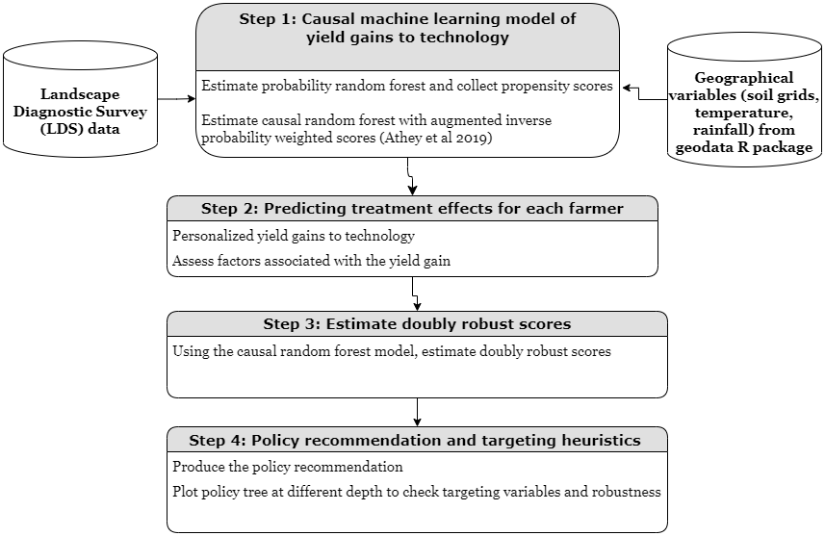

Figure 3: Causal machine learning and policy learning workflow

# 3. Results and discussion

## 3.1. Heterogeneous treatment effects

Table 1 shows the conditional average treatment effects of various agronomic practices on wheat yields. Panel (a) shows the yield gains to weed management with Sulfosulfuron+Metsulfuron giving the highest yield gains of about 0.3t/ha over no weeding followed by 24D and manual weeding. The combination of manual weeding and herbicides did not have any effect probably due to lack of power and small sample size. Panel (b) shows the effects of early sowing with with sowing earlier (1-10 Nov) getting yield gains as high as 0.7t/ha over those sowing after 16th Dec. Panel (c) reports yield gains to additional irrigation as compared to 1 irrigation. We find that an additional irrigation results in about 0.4t yield gains. Panel (d) shows the yield losses to selecting a variety other than HD 2967. Except for Super 303 and HD 2733, which have no significant yield differences to HD 2967, the rest of the varieties examined result in yield losses as compared to HD 2967. All of these competing varieties are long duration varieties(also known as early sown varieties) consistent with prior studies. As a robustness check, we also computed all these estimates using ordinary least squares and random forest models (appendices) finding small differences in the estimates.

Table 1: Conditional average treatment effects (yield gain as compared to base) using multi-armed bandit causal random forest models

|  |  |  |  |
| --- | --- | --- | --- |
| Practice | Contrasts | Estimate  (t/ha) | Standard error |
| *Panel (a)* |  |  |  |
| Weed management | Manual - No weeding | 0.27 | 0.02 |
| Weed management | Manual+ herbicides –  No weeding | 0.30 | 0.04 |
| Weed management | 24D - No weeding | 0.37 | 0.02 |
| Weed management | Sulfosulfuron+ Metsulfuron –  No weeding | 0.45 | 0.03 |
| *Panel (b)* |  |  |  |
| Sowing dates | 15Dec - 16Dec | 0.23 | 0.02 |
| Sowing dates | 30Nov - 16Dec | 0.43 | 0.02 |
| Sowing dates | 20Nov - 16Dec | 0.56 | 0.02 |
| Sowing dates | 10Nov - 16Dec | 0.73 | 0.05 |
| *Panel (c)* |  |  |  |
| Number of irrigations | Two - one | 0.39 | 0.02 |
| Number of irrigations | Three - one | 0.78 | 0.03 |
| Number of irrigations | Four - one | 1.35 | 0.05 |
| *Panel (d)* | |  |  |  |
| Variety choice | Local - HD2967 | -0.55 | 0.03 |
| Variety choice | PBW343 - HD2967 | -0.24 | 0.03 |
| Variety choice | UP262 - HD2967 | -0.53 | 0.03 |
| Variety choice | LOK1 - HD2967 | -0.60 | 0.03 |
| Variety choice | PBW154 - HD2967 | -0.46 | 0.03 |
| Variety choice | Kedar - HD2967 | -0.49 | 0.03 |
| Variety choice | SUPER303 - HD2967 | -0.05 | 0.03 |
| Variety choice | PBW502 - HD2967 | -0.21 | 0.04 |
| Variety choice | HD2733 - HD2967 | -0.09 | 0.10 |
| Variety choice | HUW234 - HD2967 | -0.61 | 0.04 |
| Variety choice | RR21 - HD2967 | -0.37 | 0.04 |

These average returns are also consistent for distributional comparisons as shown by figure 4. These distributions help to demonstrate the heterogeneity in the returns. For varieties, the only varieties that are match the yield levels of HD 2967 for all farmers are long duration varieties (timely sown varieties) like SUPER 303, HD 2733, PBW 502 and PBW 343.

Figure 4: Treatment effect heterogeneity

Note: Density plots showing the farmer specific estimated yield gains of adopting each of the crop management practices.

### 3.1.2. Who and which farm gains the most from superior crop management practices?

Using the heterogeneous treatments, we explore who is likely to benefit the most from the superior crop management practices, i.e., those practices that have highest yield gains. For all the practices, we find that farmers with the highest yield gains apply on average more nitrogen, grow a long duration variety and sow their wheat earlier (see appendix tables for actual estimates and figures for standardized estimates).

There are also interesting patterns on other variables. For example, S&M herbicide mixture and more irrigations have highest yield gain quartile at lower elevation (56.4 masl and 57.32 masl respectively) and lowest yield gain quartile at higher elevation (81.12 masl and 83.22masl). This is in contrast to early sowing in the first week of November (1-10 Nov) which has the top quartile of yield gains at higher elevation (73 masl) and the lowest quartile of yield gains at lower elevation (62 masl).

Another interesting example is phosphorus with higher quartile of yield gains for herbicides and early sowing associated with higher levels of phosphorus (about 65 and 67 kg per ha respectively). Conversely, lowest quartile farmers applied about 52 and 50 kg per ha respectively.

In terms of plot size which is usually used as a key proxy for wealth, we find that on average farmers who are in the highest quartile of early sowing yield gains are those with smaller plot sizes (0.17ha) while those in the highest quartile of herbicide weed management are those with slightly larger plot sizes (0.32ha).

In terms of the total annual precipitation (a proxy of soil moisture), we find that highest yield gain quartiles for four irrigations are in areas with high amounts of precipitation with an interquartile difference of 67mm. For early sowing however, highest yield gains are in locations with lower precipitation (with an interquartile difference of -44mm).

## 3.2. Simple bivariate mapping prioritization framework

The analysis so far presented doesnot prescribe whether the policy maker or extension agency should prioritize in encouraging any of the farmers to adopt the particular practice. All it says is that, some farmers benefit from particular treatments than others. We thus need to provide a criteria for which an extension system can use to prioritize who to target with intervations. The first approach would to assign each farmer to the treatment that gives the highest yield gains for them. We can deduce from figure 4 that the majority of the farmers would be assigned to (S&M) herbicide, early sowing (1-10 Nov), four irrigations and to two main varieties (HD 2967 and SUPER 303)[[3]](#footnote-3).

The second approach we consider is to map the prioritization zones (starting with administrative units like districts) by considering a bivariate map of percentage levels of adoption gap of the desired practice and the associated yield gains. The areas with highest levels of the adoption gap but with higher potential for yield gains with a new practice are considered priority zones for awareness interventions to increase adoption of the new practice. Similarly, areas with moderate adoption levels but very high yield potential can be prioritized for expansion interventions. For areas, with low adoption and low potential, these can prioritized for more research to understand constraints.

Figure 5 shows the bivariate maps of the CATEs and the adoption gap (defined as 1-share of farmers using the practice) for the highest performing treatments for each of the crop management practices. We find that applying Sulfosulforun & Metsulforon broad spectrum herbicide provides higher yield gains with a huge adoption potential in the mid-eastern districts of Bihar and northern EUP districts. On early sowing (before 10th November), we find that higher yield gains are in the south-western districts of Bihar where there is also a huge adoption potential. For irrigation and varieties, districts of higher yield gain potential and adoption are scattered across different regions of Bihar.

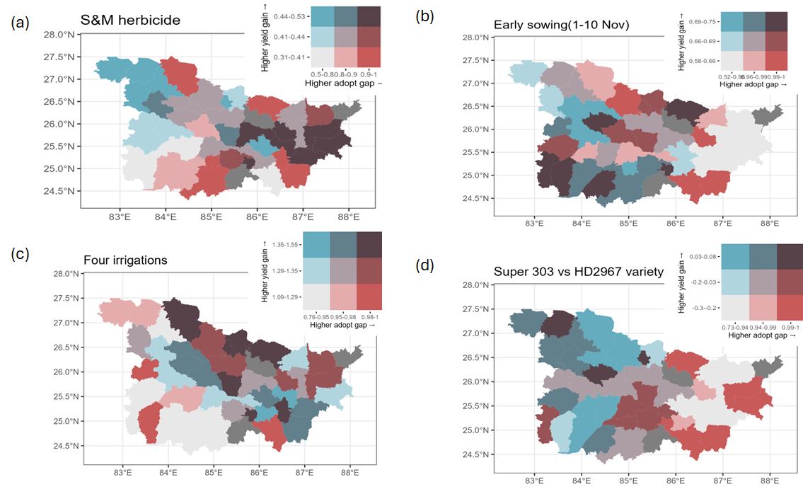

Figure 5: Bivariate map showing the yield gain potential based on heterogeneous treatment effects and adoption gap (1-share currently using the practice). Note: Yield gain is in tons per ha, S&M=Sulfusulfosoron & Metsulfusorun herbicide.

## 3.3. Minimal variables policy learning prioritization framework

### 3.3.1. How and where to target farmers to receive a recommendation?

The goal of policy learning is to be able to use a minimal set of variables to optimally assign each individual to the treatment that is most beneficial. To do that, we rely on depth 2 policy tree which allows a maximum of three variables to be used in the assignment. Figure 6 panel (a) shows the policy tree for weed management options. The policy tree shows that weed management options can be targeted to farmers on the basis of their weed severity, sowing date, and January maximum temperature. Sowing dates can be assigned on the basis of total annual precipitation, phosphorus applied and plot size (figure 6b). Conventionally, farmers apply at least two irrigations to the wheat crop in Bihar.. Using the policy tree based algorithm, we find that 93% of the farmers would benefit more from applying four irrigations. Figure 6c shows the policy tree for this recommendation. The key variables for delineating the groups of farmers include annual temperature, January maximum temperature, and elevation. The supposedly simple task of choosing a wheat variety to plant can be complicated due to variety choice overload with dozens of varieties on the market. To aid in the choosing of a variety that gives the maximal yield gains, we apply the policy tree algorithm on 12 wheat varieties that are planted by over 90% of the farmers. These varieties can be targeted on the basis longitude..

Figure 6 shows policy trees (depth 2) for the different agronomic management practices.

Figure 6: Depth 2 policy trees for decision support on agronomic practices

With this algorithm, we are able to assign each of the farmers to particular agronomic practices. We can therefore produce a spatial representation of these farmers. Figure 7 shows maps of recommended practices for each of the farmers. We find that weed management and sowing dates have more spatially dispersed recommended practices while the other practices exhibit substantial spatial clustering.

Figure 7: Spatial distribution of recommended agronomic practices based on depth 2 policy tree[[4]](#footnote-4)

### 3.3.2. How many farmers transition across agronomic management options?

Figure 8 shows the proportion of farmers who can be assigned to each of the interventions using policy tree optimization. For weed management, figure 8 panel (a) shows that the optimal transitions for yield gains are to apply broad spectrum herbicides especially Sulfosulfuron+Metsulfuron (55%) followed by 24-D (32%) and combined manual and herbicides (13%). In the case of sowing dates, farmers are advised to sow early, i.e., between 1-10 Nov for 81% of the farmers and between 11-20th Nov for 19% of the farmers. Growing evidence suggests that three or four irrigations would provide higher yield returns. The question remains as to where and to who should these additional irrigations be targeted. Perhaps the most extreme shift is recommended for irrigation management with farmers having to shift from 3 or less irrigations to four irrigations (98%).

We find that on the basis of yield maximization, three varieties can be recommended, viz. HD 2967 (50%), Shri Ram SUPER 303 (44%) AND HD 2733 (5%).

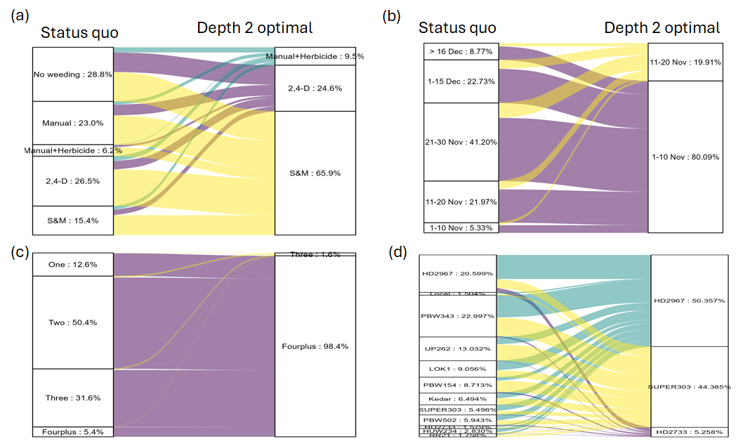

Figure 8 Optimal transition from status quo practices to optimal practices

### 3.3.3. Value of personalizing treatments relative to uniform policies for out-of-sample farmers

The depth 2 targeting policy procedure is compared against a policy of assigning all households to any of the treatments also called uniform policy.

*Depth 2 targeted weed management versus uniform policies*

Table 3 shows median percentage advantage of the depth 2 targeted policy over uniform policies in which each of the treatments is applied for all farmers. Using the targeted policy improves on the status quo especially for those not weeding at all. For those doing manual weeding already, the targeted policy only works better for the median farmer only if 2,4-D is recommended. The other options result in small losses out of sample. We find that advising all farmers to apply a safe mixture herbicide like Sulfosulfuron+Metsulfuron is on average a better policy than the depth 2 targeted strategy in out of sample prediction.

Table 3: Median percentage value of depth 2 targeted weed management policies for out-of-sample farmers over uniform policies

|  |  |  |  |  |  |  |  |  |
| --- | --- | --- | --- | --- | --- | --- | --- | --- |
|  |  |  |  | Percentage advantage of depth 2 targeted policy over uniform policies | | | | |
| Status Quo | Targeted policy | N obs | % | Over no weeding | Over manual | Over manual+herbicides | Over 2,4-D | Over S&M |
|  |  | (1) | (2) | (3) | (4) | (5) | (6) | (7) |
| No weeding | Manual +Herbicides | 228 | 7.24 | 5.09 | 2.20 | 0.00 | -1.48 | -3.45 |
| No weeding | 2,4-D | 390 | 12.38 | 16.33 | 3.88 | 2.40 | 0.00 | -2.00 |
| No weeding | S&M | 263 | 8.35 | -2.32 | 6.85 | 5.61 | 3.90 | 0.00 |
| Manual | Manual +Herbicides | 108 | 3.43 | 9.33 | -1.94 | 0.00 | -2.21 | -4.41 |
| Manual | 2,4-D | 242 | 7.68 | 12.60 | 2.50 | 1.96 | 0.00 | -2.97 |
| Manual | S&M | 359 | 11.40 | 16.01 | -8.48 | 5.37 | 3.58 | 0.00 |
| Manual +Herbicides | Manual +Herbicides | 33 | 1.05 | -6.77 | -11.87 | 0.00 | -17.00 | -18.98 |
| Manual +Herbicides | 2,4-D | 63 | 2.00 | 12.29 | 3.63 | -44.25 | 0.00 | -3.33 |
| Manual +Herbicides | S&M | 111 | 3.52 | 16.26 | 7.24 | -41.16 | 3.27 | 0.00 |
| 2,4-D | Manual +Herbicides | 88 | 2.79 | 10.02 | 2.35 | 0.00 | -11.29 | -3.35 |
| 2,4-D | 2,4-D | 307 | 9.75 | -2.94 | -8.87 | -10.71 | 0.00 | -15.87 |
| 2,4-D | S&M | 469 | 14.89 | 15.71 | 6.93 | 5.56 | 1.74 | 0.00 |
| S&M | Manual +Herbicides | 81 | 2.57 | 9.67 | 1.72 | 0.00 | -2.01 | -1.98 |
| S&M | 2,4-D | 80 | 2.54 | 12.67 | 3.32 | 2.41 | 0.00 | -18.31 |
| S&M | S&M | 328 | 10.41 | 16.08 | 6.02 | 5.71 | 2.61 | 0.00 |

Note: S&M=Sulfosulfuron + Metsulfuron

Similarly on sowing window optimal choice, we find that the targeted policy is better than all uniform policies except for sowing in the 1-10 Nov window. Should those who are sowing in the window Nov 11 -Nov 20 be advised to advance sowing date to Nov 1-Nov 10? Table 4 shows that at median this is not a good decision because this can lead to losses of about 4.76 percent.

Table 4: Median percentage value of depth 2 targeted sowing policies for out-of-sample farmers over uniform policies

|  |  |  |  |  |  |  |  |  |
| --- | --- | --- | --- | --- | --- | --- | --- | --- |
|  |  |  |  | Percentage advantage of depth 2 targeted policy over uniform policies | | | | |
| Status quo sowing window | Targeted policy | N obs | % | Over After Dec 16 | Dec 1-Dec 15 | Nov 21-Nov 30 | Nov 11-Nov 20 | Nov 1-Nov 10 |
|  |  | (1) | (2) | (3) | (4) | (5) | (6) | (7) |
| After Dec 16 | Nov 11-Nov 20 | 79 | 2.14 | -33.56 | 12.02 | 4.73 | 0.00 | -3.00 |
| After Dec 16 | Nov 1-Nov 10 | 249 | 6.75 | 7.15 | 17.61 | 9.90 | 4.62 | 0.00 |
| Dec 1-Dec 15 | Nov 11-Nov 20 | 233 | 6.32 | 20.93 | 7.43 | 4.58 | 0.00 | -2.59 |
| Dec 1-Dec 15 | Nov 1-Nov 10 | 589 | 15.97 | 28.20 | 14.45 | 9.22 | 4.17 | 0.00 |
| Nov 21-Nov 30 | Nov 11-Nov 20 | 538 | 14.58 | 20.53 | 10.82 | 5.07 | 0.00 | -2.65 |
| Nov 21-Nov 30 | Nov 1-Nov 10 | 970 | 26.29 | 26.34 | 15.65 | 10.71 | 3.88 | 0.00 |
| Nov 11-Nov 20 | Nov 11-Nov 20 | 275 | 7.45 | 22.39 | 13.09 | 6.89 | 0.00 | -0.61 |
| Nov 11-Nov 20 | Nov 1-Nov 10 | 557 | 15.10 | 24.85 | 14.90 | 8.03 | -4.76 | 0.00 |
| Nov 1-Nov 10 | Nov 11-Nov 20 | 67 | 1.82 | 18.48 | 9.94 | 4.35 | 0.00 | -37.44 |
| Nov 1-Nov 10 | Nov 1-Nov 10 | 132 | 3.58 | 27.85 | 17.86 | 11.27 | 6.23 | 0.00 |

We find similar results for the case of irrigations and variety management with the targeted policy providing much higher out-of-sample performance that any of the uniform policies except in cases where the best overall technology is not prescribe by the depth 2 policy (see appendix tables).

### 3.3.4. Including production, targeting and environmental costs in policy evaluation: Illustrative irrigation example[[5]](#footnote-5)

The results so far are based on yield benefits of the technology options. The policy tree algorithm however allows one to embed a cost function or any other complex functions of the yield gains. For example, we could include irrigation costs, costs of implementing the targeting policy and environmental costs associated with groundwater overextraction.

To include the input cost, we can simply substract a yield equivalent cost from the double robust scores and use the policy tree optimization to reassign.

For illustrative purposes, we consider the case of including production costs. To simplify, the problem, we assume that farmers are the same output price at Rs. 15 per kg. (or Rs. 15,000 per ton). On average, the farmers pay Rs. 120 per hour for one irrigation (10 hours) per ha or Rs. 1200 per ha. In wheat yield equivalents, this irrigation cost can buy 0.08 tons of wheat. Using this arithmetic, two irrigations can pay 0.16 tons of wheat, three irrigations can pay 0.24 tons of wheat and four irrigations can pay 0. 32 tons of wheat.

Even after including the cost of irrigation, almost 87% of the farmers are recommended to apply four irrigations (Figure 9). This is because yield gains are higher enough to cover the cost of irrigation. The evidence seems to be clear that farmers would gain from either three or four irrigations and that the cost of the irrigation seems to matter less in this decision because the revenue gains are so enormous.

Figure 9: Targeting irrigation assuming costs (note: Revenue gain: Rs. 15/kg x Yield gain, irrigation cost: Rs. 120/hr x 10 hrs=1200/ha for 1 irrigation (80kg), Rs. 2400 for 2 irrigations (160kg), Rs. 3600 for 3 irrigations (240kg wheat equiv.), and Rs. 4800 for 4 irrigations (320kg wheat equiv.).

# 4. Implementation and policy implications

## 4.1. The value of data-driven personalized agricultural recommendations

The idea of context specific agricultural recommendations has been advanced for many decades in agriculture. This goal led to many fields of agriculture including precision agriculture, and site-specific management. The challenge has been that for one to understand all the combinations of contexts, it requires large number of observations than would be cost-effectively be collected. In this regards, machine learning algorithms have allowed analysis of complex interactions of different contexts for which recommendations can be made. Applications in agriculture while growing rapidly, the idea using these data-driven approaches to personalize the recommendations that the extension system uses have not been extensively explored.

In this paper, we have demonstrated that by using a causal machine learning framework, one can develop personalized recommendations for farmers in the sample as well as approximate a policy for recommending to all farmers in the area of interest.

These personalized recommendations can also be aggregated to district or other spatial units to facilitate efficient targeting.

Digital agricultural services are rapidly being deployed in developing countries without proper backend analytics. The approach we demonstrated is a scalable approach that can be integrated in digital services like mobile apps to provide evidence-based personalized recommendations.

## 4.2. Generation of recommendations in real world settings

The causal machine learning and targeting procedures we have outlined present opportunities for personalized digital and traditional advisories to smallholder farmers. The heterogenous effects allow us to prioritize which locations require advisory support based on the yield gains while the policy tree optimization approach allows us to identify which limited set of variables can be used to target the treatments. We suggest several applications for which the causal machine learning and policy learning approach we have presented can be used in current data-scarce environments.

First, the personalized agricultural recommendations framework can be used in developing adaptive agriculture experiments that not only allow discovery of treatments that work for smallholder farmers but allowing farmers to benefit from the research by testing only those treatments that work better for their contexts. In this respect, the approach can be used in transporting results in both time and space.

Second, the approach can be used to analyze baseline survey datasets which are routinely collected by agricultural development projects. In that way, the analytics can help in designing complementary interventions that would facilitate adoption and impacts of the interventions. For example, Athey et al (2023) used observational data and the causal machine learning to identify better times to make extension calls to farmers in Odisha.

Third, agricultural policy making requires evidence of the spatially differentiated yield gains so that one can envisage the likely market level implications. Most agricultural innovations were assessed at a much higher spatial unit (e.g., a country) because of lack of such evidence.

# 5. Conclusion

The paper has introduced the concept of “personalized agronomy” made possible by causal machine learning models for estimating individual treatment effects and policy tree models for generating optimal recommendations. These models have been effective in “personalized medicine” and we conjecture agricultural scientists would also use these models in making personalized crop management recommendations. In agricultural context, a recent study by Athey et al (2023) has piloted the use of causal machine learning based recommender systems and have found them to be better than conventional approaches. One challenge of this approach is that each agronomic practice is analysed separately. What combinations of these are likely to be the most profitable for each farmer? For our application, this seems not to be an issue as the recommended practices can be implemented together but this may not be the case in other applications.

There are several aspects that require further research to effectively use the approach for policy. First, the recommended practices are proposed on the basis of yield and partial profits yet there may be other important factors when evaluating the recommended practices. For example, while applying more irrigation is profitable to individual farmers, it may lead to groundwater overexploitation. A multi-criteria evaluation of these proposed strategies is needed and policy tree extensions for multiobjective extensions (Athey et al 2023, Athey et al 2024a) are available to address such concerns. Second, the estimation of the treatment effects requires enough observations for each of the practices to guarantee balanced comparisons. In the case of new agronomic innovations, it may be that only few farmers have adopted the technology as such there is not enough sample to make comparisons. This is a key limitation in the analysis of herbicides and varieties which are substantially differentiated and there are many other new variants that only few farmers have adopted. These areas of improvement for the approach however also apply even in conventional approaches. The advances in causal machine learning however present a future of the possibility of experimenting personalized agricultural recommendations at large scales.

# Acknowledgements

This paper was prepared with support from the Bill and Melinda Gates Foundation through the Cereal Systems Initiative for South Asia (CSISA) and the Excellence in Agronomy (EiA) Initiative of the CGIAR. We thank all the CSISA field teams who supported the collection of the Landscape Diagnostic Survey (LDS). We also thank the farmers who provided their precious time to respond to survey questions. The content of this report solely reflects the opinions and findings of the authors.

# References

Alston, J.M., Pardey, P.G., and Rao, X. 2022. “Payoffs to a half century of CGIAR research.” *American Journal of Agricultural Economics* 104 (2): 502-529. Doi: <https://doi.org/10.1111/ajae.12255>.

Athey, S., Tibshirani, J., and Wager, S. 2019. “Generalized Random Forests”. *Annals of Statistics* 47 (2): 1148-1178. Doi: 10.1214/18-AOS1709.

Athey, S., and Wager, S. 2021. “Policy learning with observational data.” *Econometrica* 89(1): 133-161. Doi: <https://doi.org/10.3982/ECTA15732>.

Athey, S., Cole, S., Nath, S., Zhu, J. 2023. “Targeting, personalization, and engagement in an agricultural advisory service”. Working paper. Url: <http://dx.doi.org/10.2139/ssrn.4536641>.

Athey, S., Byambadalai, U., Cersosimo, M., Koutout, K., and Nath, S. 2024a. “The Heterogenous Impact of Changes in Default Gift Amounts on Fundraising”. Working paper. Url: [http://dx.doi.org/10.2139/ssrn.4785704](https://dx.doi.org/10.2139/ssrn.4785704" \t "_blank).

Athey, S., Simon, L.K., Skans, O.N., Vikstrom, J., and Yakymovych, Y. 2024b. “The Heterogeneous Earnings Impact of Job Loss Across Workers, Establishments, and Markets”. Working paper. Url: <https://doi.org/10.48550/arXiv.2307.06684>.

Cagala, T., Glogowsky, U., Rincke, J., and Strittmatter, A. 2021. “Optimal targeting in fundraising: A causal machine learning approach”. Working paper. Url: <https://arxiv.org/abs/2103.10251>.

Cambron, T.W., Deines, J.M., Lopez, B., Patel, R., Liang, S., and Lobell, D.B. 2024. “Further adoption of conservation tillage can increase maize yields in the Western U.S. Corn Belt”. *Environmental Research Letters* 19: 054040. Doi: 10.1088/1748-9326/ad3f32.

Cameron-Harp, M., Hendricks, N.P., and Potter, N.A. 2024. “Predicting the spatial variation in cost-efficiency for agricultural greenhouse gas mitigation programs in the U.S”. *Carbon Balance and Management* 19: 16. Doi: <https://doi.org/10.1186/s13021-024-00252-6>.

Credit, K., and Lehnert, M. 2023. “A structured comparison of causal machine learning methods to assess heterogenous treatment effects in spatial data” *Journal of Geographical Systems.* Doi: <https://doi.org/10.1007/s10109-023-00413-0>.

Deines, J.M., Guan, K., Lopez, B., Zhou, Q., White, C.S., Wang, S., Lobell, D.B. 2022. “Recent cover crop adoption is associated with small maize and soybean yield losses in the United States”. *Global Change Biology* 29 (3): 794-807. Doi: <https://doi.org/10.1111/gcb.16489>.

Dahabreh, I.J., Robertson, S.E., Steingrimsson, J.A., Stuart, E.A., Hernan, M.A. 2020. “Extending inferences from a randomized trial to a new target population”. Statistics in Medicine 39 (14): 1999-2014. Doi: <https://doi.org/10.1002/sim.8426>.

Giannarakis, G., Sitokonstantinou, V., Lorilla, R.S., Kontoes, C. 2022. “Towards assessing agricultural land suitability with causal machine learning”. Url: <https://arxiv.org/abs/2204.12956>.

Haile, B., Azzarri, C., Roberts, C., Spielman, D.J. 2017. “Targeting, bias, and expected impact of complex innovations on developing-country agriculture: evidence from Malawi.” *Agricultural Economics* 48 (3): 317-326. Doi:  <https://doi.org/10.1111/agec.12336>.

Inoue, K., Athey, S., and Tsugawa, Y. 2023. “Machine-learning-based high-benefit approach versus conventional high-risk approach in blood pressure management.” *International Journal of Epidemiology* 1-14. Doi: <https://doi.org/10.1093/ije/dyad037>.

Jones, E.J., Bishop, T.F.A., Malone, B.P., Hulme, P.J., Whelan, B.M., and Filippi, P. 2022. “Identifying causes of crop yield variability with interpretive machine learning”. *Computers and Electronics in Agriculture* 192: 106632. Doi: <https://doi.org/10.1016/j.compag.2021.106632>.

Kakimoto, S., Mieno, T., Tanaka, T.S.T., and Bullock, D.S. 2022. “Causal forest approach for site-specific input management via on-farm precision experimentation”. *Computers and Electronics in Agriculture* 199: 107164. Doi: <https://doi.org/10.1016/j.compag.2022.107164>.

Kitagawa, T., and Tetenov, A. 2018. “Who should be treated? Empirical welfare maximization methods for treatment choice.” *Econometrica* 86 (2): 591-616. Doi: <https://doi.org/10.3982/ECTA13288>.

Kluger, D.M., Owen, A.B., Lobell, D.B. 2022. “Combining randomized field experiments with observation satellite data to assess the benefits of crop rotation on yields”. *Environmental Research Letters* 17 (4): 044066. Doi: 10.1088/1748-9326/ac6083.

Krishna, V.V., Keil, A., Jain, M., Zhou, W., Jose, M., Serendran-Padmaja, S., Barba-Escoto, L., Balwinder-Singh, Jat, M.L., Erenstein, O. 2022. “Conservation Agriculture Benefits Indian Farmers, but Technology Targeting Needed for Greater Impacts.” *Frontiers in Agronomy*. Doi:10.3389/fagro.2022.772732.

Krupnik, T.J., Ahmed, Z.U., Timsina, J., Yasmin, S., Hossain, F., Al Mamun, A., Mridha, A.I., and McDonald, A.J. 2015. “Untangling crop management and environmental influences on wheat yield variability in Bangladesh: An application of non-parametric approaches.” *Agricultural Systems* 139: 166-179. Doi: <https://doi.org/10.1016/j.agsy.2015.05.007>.

McCullough, E.B., Quinn, J.D., Simons, A.M. 2022. “Profitability of climate-smart soil fertility investment varies widely across sub-Saharan Africa”. *Nature Food* 3: 275-285. Doi: <https://doi.org/10.1038/s43016-022-00493-z>.

McDonald, A.J., Malik, R.K., Ajay, A., Craufurd, P., Dubey, S., Gautam, U., Karki, S., Kishore, A., and Krupnik, T.J., Kumar, V., Mkondiwa, M., Nayak, H.S., Parihar, C.M., Paudel, G., Peramaiyan, P., Pundir, A., Poonia, S., Samaddar, A., Sherpa, S., Singh, B., Singh, S., Urfels, A., Veettil, P., and Pathak, H., and Singh, A. K. “Bigger Data from Landscape-Scale Crop Assessment Surveys Empowers Sustainability Transitions.” Url: [http://dx.doi.org/10.2139/ssrn.4511866](https://dx.doi.org/10.2139/ssrn.4511866).

Mulungu, K., Abro, Z.A., Muriithi, W.B., Kassie, M., Kidoido, M., Sevgan, S., Mohamed, S., Tanga, C. and Khamis, F. 2023. “One size does not fit all: Heterogenous economic impact of integrated pest management practices for mango fruit flies in Kenya—a machine learning approach”. *Journal of Agricultural Economics* 75 (1): 261-279. Doi: <https://doi.org/10.1111/1477-9552.12550>.

Quigley, D.T., Che, Y., Yasar, M., and Rejesus, R.M. 2023. “Cover crop adoption and climate risks: An application of causal random forests”. Agriculrual and Applied Economics Association (AAEA). Doi: <https://ageconsearch.umn.edu/record/335586/files/25617.pdf>.

Snapp, S. 2022. “Embracing variability in soils on smallholder farms: New tools and better science”. Agricultural Systems 195: 103310. Doi: [https://doi.org/10.1016/j.agsy.2021.103310](https://doi.org/10.1016/j.agsy.2021.103310" \t "_blank" \o "Persistent link using digital object identifier).

Stetter, C., Mennig, P., and Sauer, J. 2022. “Using machine learning to identify heterogeneous impacts of agri-environment schemes in the EU: A case study”. European Review of Agricultural Economics 49 (4): 723-759. Doi: <https://doi.org/10.1093/erae/jbab057>.

Stokes, M.E., and McCourt, P. 2014. “Towards personalized agriculture: what chemical genomics can bring to plant biotechnology.” Frontiers in Plant Science 5. Doi: <https://doi.org/10.3389/fpls.2014.00344>.

Suri, T. and Udry, C., 2022. Agricultural technology in Africa. Journal of Economic Perspectives, 36(1), pp.33-56.

Suri, T., 2011. Selection and comparative advantage in technology adoption. Econometrica, 79(1), pp.159-209.

Sverdrup, E., Kanodia, A., Zhou, Z., Athey , S., and Wager, S. 2020. “policytree: Policy learning via doubly robust empirical welfare maximization over trees”. Journal of Open Source Software 5 (50), 2232. Doi: <https://doi.org/10.21105/joss.02232>.

Tanaka, T.S.T., Heuvelink, G.B.M., Mieno, T., and Bullock, D.S. 2024. “Can machine learning models provide accurate fertilizer recommendations?” Precision Agriculture 25, 1839-1856. Doi: <https://doi.org/10.1007/s11119-024-10136-x>.

Urfels, A., McDonald, A.J., Halsema, G., Struik, P.C., Kumar, P., Malik, R.K., Poonia, S.P., Balwinder-Singh, Singh, D.K., Singh, M., and Krupnik, T.J. 2021. “Social-ecological analysis of timely rice planting in Eastern India.” Agronomy for Sustainable Development 41: 14. Doi: <https://doi.org/10.1007/s13593-021-00668-1>.

Wager, S., and Athey, S. 2018. “Estimation and Inference of Heterogeneous Treatment Effects using Random Forests”. Journal of the American Statistical Association 113(523): 1228-1242. Doi: <https://doi.org/10.1080/01621459.2017.1319839>.

Zhou, Z., Athey, S., Wager, S. 2022. “Offline multi-action policy learning: Generalization and optimization.” Operations Research 71 (1): 148-183. Doi: <https://doi.org/10.1287/opre.2022.2271>.

# Appendices

## Tables

Table A1: Descriptive statistics

|  |  |  |  |  |  |  |  |
| --- | --- | --- | --- | --- | --- | --- | --- |
| Variables | Mean | Stdev | Minimum | Lower quartile | Median | Upper quartile | Maximum |
| Wheat yield (ton/ha) | 2.99 | 0.85 | 0.20 | 2.40 | 3.00 | 3.43 | 6.50 |
| Number of irrigations | 2.29 | 0.77 | 1.00 | 2.00 | 2.00 | 3.00 | 5.00 |
| One irrigation (share) | 0.13 | 0.34 | 0.00 | 0.00 | 0.00 | 0.00 | 1.00 |
| Two irrigations (share) | 0.50 | 0.50 | 0.00 | 0.00 | 1.00 | 1.00 | 1.00 |
| Three irrigations (share) | 0.31 | 0.46 | 0.00 | 0.00 | 0.00 | 1.00 | 1.00 |
| Four or more irrigations (share) | 0.05 | 0.23 | 0.00 | 0.00 | 0.00 | 0.00 | 1.00 |
| Sowing date: after 16th Dec | 0.09 | 0.28 | 0.00 | 0.00 | 0.00 | 0.00 | 1.00 |
| Sowing date: 1st Dec-15th Dec | 0.22 | 0.42 | 0.00 | 0.00 | 0.00 | 0.00 | 1.00 |
| Sowing date: 21st Nov-30th Nov | 0.41 | 0.49 | 0.00 | 0.00 | 0.00 | 1.00 | 1.00 |
| Sowing date: 11th Nov-20th Nov | 0.22 | 0.42 | 0.00 | 0.00 | 0.00 | 0.00 | 1.00 |
| Sowing date: 1-10th Nov | 0.05 | 0.23 | 0.00 | 0.00 | 0.00 | 0.00 | 1.00 |
| No schooling | 0.27 | 0.45 | 0.00 | 0.00 | 0.00 | 1.00 | 1.00 |
| Primary | 0.30 | 0.46 | 0.00 | 0.00 | 0.00 | 1.00 | 1.00 |
| Matriculation | 0.21 | 0.41 | 0.00 | 0.00 | 0.00 | 0.00 | 1.00 |
| Senior secondary | 0.11 | 0.31 | 0.00 | 0.00 | 0.00 | 0.00 | 1.00 |
| Bachelors | 0.09 | 0.28 | 0.00 | 0.00 | 0.00 | 0.00 | 1.00 |
| Post grad | 0.02 | 0.14 | 0.00 | 0.00 | 0.00 | 0.00 | 1.00 |
| Nitrogen per ha | 130.22 | 37.04 | 0.00 | 105.19 | 132.54 | 156.00 | 298.47 |
| Phosphate per ha | 59.04 | 19.63 | 0.00 | 45.43 | 59.78 | 72.69 | 212.96 |
| Weeded | 0.76 | 0.43 | 0.00 | 1.00 | 1.00 | 1.00 | 1.00 |
| Timely sown variety | 0.53 | 0.50 | 0.00 | 0.00 | 1.00 | 1.00 | 1.00 |
| Weed severity (1-4) | 2.72 | 0.76 | 1.00 | 2.00 | 3.00 | 3.00 | 4.00 |
| Disease severity (1-4) | 1.47 | 0.70 | 1.00 | 1.00 | 1.00 | 2.00 | 4.00 |
| Insect severity (1-4) | 1.60 | 0.76 | 1.00 | 1.00 | 1.00 | 2.00 | 4.00 |
| Drought severity (1-4) | 1.94 | 0.88 | 1.00 | 1.00 | 2.00 | 3.00 | 4.00 |
| Temperature | 26.06 | 0.31 | 24.98 | 25.92 | 26.05 | 26.23 | 26.61 |
| Total annual precipitation (mm) | 953.77 | 254.25 | 599.80 | 741.20 | 890.90 | 1191.60 | 1874.40 |
| Elevation (m) | 68.33 | 21.49 | 27.00 | 54.00 | 67.00 | 79.00 | 327.00 |
| Distance to market (km) | 4.41 | 4.11 | 0.00 | 2.00 | 3.00 | 6.00 | 55.00 |
| Largest plot area (ha) | 0.25 | 0.27 | 0.01 | 0.11 | 0.18 | 0.28 | 8.10 |
| Marginalized caste | 0.76 | 0.43 | 0.00 | 1.00 | 1.00 | 1.00 | 1.00 |
| Plot owned | 0.81 | 0.39 | 0.00 | 1.00 | 1.00 | 1.00 | 1.00 |
| Gender (female) | 0.03 | 0.17 | 0.00 | 0.00 | 0.00 | 0.00 | 1.00 |
| Soil nitrogen | 1.60 | 0.21 | 1.10 | 1.50 | 1.60 | 1.70 | 2.70 |
| Soil sand | 29.88 | 3.02 | 19.00 | 28.00 | 30.00 | 32.00 | 47.00 |
| Soil organic carbon | 12.70 | 2.32 | 7.30 | 11.10 | 12.60 | 14.10 | 24.30 |

Table A2: OLS results [no long lat]

|  |  |  |  |
| --- | --- | --- | --- |
| Prace | Contrasts | Estimate (t/ha) | std.error |
| *Panel (a)* |  |  |  |
| Weed management | Manual - No weeding | 0.178\*\*\* | -0.025 |
| Weed management | Manual+ herbicides – No weeding | 0.188\*\*\* | -0.041 |
| Weed management | 24D - No weeding | 0.284\*\*\* | -0.026 |
| Weed management | Sulfosulfuron+ Metsulfuron –  No weeding | 0.375\*\*\* | -0.030 |
| *Panel (b)* |  |  |  |
| Sowing dates | 15Dec - 16Dec | 0.241\*\*\* | -0.034 |
| Sowing dates | 30Nov - 16Dec | 0.401\*\*\* | -0.035 |
| Sowing dates | 20Nov - 16Dec | 0.597\*\*\* | -0.039 |
| Sowing dates | 10Nov - 16Dec | 0.706\*\*\* | -0.052 |
| *Panel (c)* |  |  |  |
| Number of irrigations | Two - one | 0.361\*\*\* | -0.029 |
| Number of irrigations | Three - one | 0.679\*\*\* | -0.032 |
| Number of irrigations | Four - one | 1.293\*\*\* | -0.050 |
| *Panel (d)* |  |  |  |
| Variety choice | Local - HD2967 | -0.354\*\*\* | -0.076 |
| Variety choice | PBW343 - HD2967 | -0.215\*\*\* | -0.032 |
| Variety choice | UP262 - HD2967 | -0.429\*\*\* | -0.034 |
| Variety choice | LOK1 - HD2967 | -0.390\*\*\* | -0.044 |
| Variety choice | PBW154 - HD2967 | -0.297\*\*\* | -0.037 |
| Variety choice | Kedar - HD2967 | -0.301\*\*\* | -0.046 |
| Variety choice | SUPER303 - HD2967 | -0.140\*\* | -0.043 |
| Variety choice | PBW502 - HD2967 | -0.260\*\*\* | -0.045 |
| Variety choice | HD2733 - HD2967 | -0.118 | -0.072 |
| Variety choice | HUW234 - HD2967 | -0.471\*\*\* | -0.056 |
| Variety choice | RR21 - HD2967 | -0.493\*\*\* | -0.072 |

Table A3: Tests of causal random forest predictive accuracy on held-out data

|  |  |  |  |
| --- | --- | --- | --- |
|  |  | Estimate | Std. Error |
| Weed management |  |  |  |
|  | Mean forest prediction | 1.10 | 0.06 |
|  | Differential forest prediction | 2.16 | 0.23 |
| Sowing date |  |  |  |
|  | Mean forest prediction | 1.08 | 0.08 |
|  | Differential forest prediction | 2.04 | 0.28 |
| Irrigation |  |  |  |
|  | Mean forest prediction | 1.07 | 0.04 |
|  | Differential forest prediction | 1.82 | 0.13 |
| Variety |  |  |  |
|  | Mean forest prediction | 1.04 | 0.07 |
|  | Differential forest prediction | 2.06 | 0.23 |

Note: A well calibrated model has significant and close to 1 estimates for both mean forest prediction and differential forest prediction.

Table A4: S&M yield gains quantiles by observable variables [no lat long model]

|  |  |  |  |  |  |
| --- | --- | --- | --- | --- | --- |
|  |  | Q1 | Q1 | Q3 | Q4 |
|  | Yield gain | [0.219,0.365] | (0.365,0.412] | (0.412,0.462] | (0.462,0.607] |
|  | N obs | 1575 | 1575 | 1574 | 1575 |
|  | % | 25 | 25 | 24.99 | 25 |
| Jan\_tmin\_18 | Mean | 9.84 | 9.69 | 9.68 | 9.71 |
|  | Std.Dev | 0.34 | 0.26 | 0.22 | 0.19 |
| Feb\_tmin\_18 | Mean | 14.33 | 13.86 | 13.58 | 13.58 |
|  | Std.Dev | 0.51 | 0.59 | 0.47 | 0.3 |
| Mar\_tmin\_18 | Mean | 18.85 | 18.13 | 17.63 | 17.63 |
|  | Std.Dev | 0.74 | 0.96 | 0.75 | 0.47 |
| Apr\_tmin\_18 | Mean | 23.09 | 22.58 | 21.79 | 21.54 |
|  | Std.Dev | 1.04 | 1.47 | 1.29 | 0.79 |
| Jan\_tmax\_18 | Mean | 22.26 | 22.31 | 22.48 | 22.47 |
|  | Std.Dev | 0.37 | 0.48 | 0.49 | 0.43 |
| Feb\_tmax\_18 | Mean | 27.31 | 27 | 26.83 | 26.78 |
|  | Std.Dev | 0.4 | 0.47 | 0.46 | 0.42 |
| Mar\_tmax\_18 | Mean | 33.22 | 32.75 | 32.34 | 32.2 |
|  | Std.Dev | 0.59 | 0.7 | 0.6 | 0.51 |
| Apr\_tmax\_18 | Mean | 36.9 | 35.89 | 34.88 | 34.75 |
|  | Std.Dev | 0.93 | 1.43 | 1.39 | 1.24 |
| Weed severity | Mean | 2.75 | 2.69 | 2.76 | 2.67 |
|  | Std.Dev | 0.72 | 0.76 | 0.75 | 0.76 |
| Disease severity | Mean | 1.71 | 1.47 | 1.42 | 1.34 |
|  | Std.Dev | 0.77 | 0.67 | 0.67 | 0.65 |
| Insect severity | Mean | 1.78 | 1.56 | 1.56 | 1.63 |
|  | Std.Dev | 0.79 | 0.71 | 0.73 | 0.78 |
| N | Mean | 120.71 | 127.74 | 132.89 | 136.15 |
|  | Std.Dev | 41.55 | 37.53 | 34.19 | 31.64 |
| Phosphate | Mean | 52.74 | 57.26 | 60.6 | 65.26 |
|  | Std.Dev | 20.68 | 19.33 | 17.73 | 18.58 |
| Long duration variety | Mean | 0.2 | 0.39 | 0.57 | 0.82 |
|  | Std.Dev | 0.4 | 0.49 | 0.5 | 0.38 |
| Irrigation times | Mean | 2.22 | 2.15 | 2.18 | 2.56 |
|  | Std.Dev | 0.81 | 0.78 | 0.67 | 0.68 |
| Sowing date window | Mean | 2.1 | 2.7 | 3.1 | 3.62 |
|  | Std.Dev | 0.82 | 0.92 | 0.82 | 0.82 |
| Gender | Mean | 0.04 | 0.03 | 0.03 | 0.03 |
|  | Std.Dev | 0.19 | 0.16 | 0.18 | 0.17 |
| Annual temperature (2017) | Mean | 26.04 | 26.08 | 26.05 | 26.05 |
|  | Std.Dev | 0.33 | 0.31 | 0.3 | 0.3 |
| Annual precipitation (2017) | Mean | 895.22 | 937.87 | 978.39 | 1023.09 |
|  | Std.Dev | 205.51 | 238.28 | 266.57 | 284.01 |
| Elevation (masl) | Mean | 81.12 | 68.71 | 62.05 | 56.04 |
|  | Std.Dev | 23.58 | 20.86 | 18.6 | 15.92 |
| Distance to market (km) | Mean | 5.47 | 3.97 | 4.13 | 4.53 |
|  | Std.Dev | 4.45 | 3.69 | 4.09 | 3.76 |
| Plot size (ha) | Mean | 0.16 | 0.22 | 0.23 | 0.32 |
|  | Std.Dev | 0.13 | 0.24 | 0.24 | 0.31 |
| Education | Mean | 1.39 | 1.46 | 1.4 | 1.58 |
|  | Std.Dev | 1.24 | 1.32 | 1.31 | 1.38 |
| Marginalized caste | Mean | 0.81 | 0.74 | 0.77 | 0.73 |
|  | Std.Dev | 0.4 | 0.44 | 0.42 | 0.44 |
| Plot owned | Mean | 0.77 | 0.79 | 0.79 | 0.85 |
|  | Std.Dev | 0.42 | 0.41 | 0.4 | 0.36 |
| Soil nitrogen | Mean | 1.7 | 1.59 | 1.55 | 1.58 |
|  | Std.Dev | 0.21 | 0.24 | 0.21 | 0.19 |
| Soil sand | Mean | 28.32 | 29.71 | 30.74 | 30.76 |
|  | Std.Dev | 3.15 | 3.06 | 3.01 | 2.31 |
| Soil organic carbon | Mean | 12.21 | 12.63 | 12.96 | 13.37 |
|  | Std.Dev | 2.67 | 2.61 | 2.08 | 1.87 |

Table A5: Nov 1-10 sowing window yield gains [no long lat model]

|  |  |  |  |  |  |
| --- | --- | --- | --- | --- | --- |
|  |  | Q1 | Q2 | Q3 | Q4 |
|  | Yield gains | [0.379,0.626] | (0.626,0.682] | (0.682,0.735] | (0.735,0.903] |
|  | N obs | 1845 | 1844 | 1844 | 1845 |
|  | % | 25.01 | 24.99 | 24.99 | 25.01 |
| Jan\_tmin\_18 | Mean | 9.75 | 9.72 | 9.7 | 9.7 |
|  | Std.Dev | 0.28 | 0.26 | 0.25 | 0.25 |
| Feb\_tmin\_18 | Mean | 13.77 | 13.76 | 13.8 | 13.92 |
|  | Std.Dev | 0.57 | 0.56 | 0.55 | 0.59 |
| Mar\_tmin\_18 | Mean | 17.89 | 17.94 | 18.05 | 18.26 |
|  | Std.Dev | 0.91 | 0.9 | 0.88 | 0.89 |
| Apr\_tmin\_18 | Mean | 21.85 | 22.12 | 22.36 | 22.7 |
|  | Std.Dev | 1.22 | 1.27 | 1.34 | 1.34 |
| Jan\_tmax\_18 | Mean | 22.56 | 22.45 | 22.33 | 22.23 |
|  | Std.Dev | 0.48 | 0.46 | 0.46 | 0.4 |
| Feb\_tmax\_18 | Mean | 27.02 | 27.01 | 26.96 | 26.99 |
|  | Std.Dev | 0.44 | 0.49 | 0.5 | 0.49 |
| Mar\_tmax\_18 | Mean | 32.53 | 32.63 | 32.66 | 32.81 |
|  | Std.Dev | 0.64 | 0.73 | 0.74 | 0.72 |
| Apr\_tmax\_18 | Mean | 35.36 | 35.62 | 35.7 | 36.04 |
|  | Std.Dev | 1.36 | 1.51 | 1.57 | 1.5 |
| Weed severity | Mean | 2.77 | 2.71 | 2.69 | 2.69 |
|  | Std.Dev | 0.74 | 0.76 | 0.77 | 0.73 |
| Disease severity | Mean | 1.53 | 1.45 | 1.45 | 1.45 |
|  | Std.Dev | 0.73 | 0.69 | 0.7 | 0.69 |
| Insect severity | Mean | 1.62 | 1.58 | 1.63 | 1.59 |
|  | Std.Dev | 0.76 | 0.74 | 0.78 | 0.76 |
| N | Mean | 102.49 | 121.15 | 141.3 | 157.18 |
|  | Std.Dev | 33.7 | 29.75 | 30.55 | 28.12 |
| Phosphate | Mean | 50.45 | 56.4 | 62 | 67.01 |
|  | Std.Dev | 16.49 | 17.8 | 19.28 | 20.36 |
| Long duration variety | Mean | 0.44 | 0.54 | 0.56 | 0.54 |
|  | Std.Dev | 0.5 | 0.5 | 0.5 | 0.5 |
| Irrigatiom times | Mean | 2.12 | 2.23 | 2.37 | 2.48 |
|  | Std.Dev | 0.76 | 0.72 | 0.73 | 0.78 |
| Gender | Mean | 0.03 | 0.03 | 0.02 | 0.04 |
|  | Std.Dev | 0.16 | 0.16 | 0.16 | 0.19 |
| Annual temperature (2017) | Mean | 25.88 | 26.07 | 26.12 | 26.16 |
|  | Std.Dev | 0.36 | 0.28 | 0.25 | 0.22 |
| Annual precipitation (2017) | Mean | 991.18 | 934.92 | 943.26 | 947.17 |
|  | Std.Dev | 299.28 | 251.02 | 232.9 | 223.86 |
| Elevation (masl) | Mean | 62.12 | 67.84 | 68.19 | 73.33 |
|  | Std.Dev | 21.77 | 21.74 | 20.41 | 19.81 |
| Distance to market (km) | Mean | 4.34 | 4.45 | 4.59 | 4.17 |
|  | Std.Dev | 3.8 | 3.82 | 4.22 | 4.17 |
| Plot size (ha) | Mean | 0.3 | 0.27 | 0.24 | 0.17 |
|  | Std.Dev | 0.31 | 0.28 | 0.25 | 0.2 |
| Education | Mean | 1.57 | 1.53 | 1.5 | 1.36 |
|  | Std.Dev | 1.37 | 1.37 | 1.31 | 1.24 |
| Marginalized caste | Mean | 0.75 | 0.74 | 0.75 | 0.79 |
|  | Std.Dev | 0.43 | 0.44 | 0.43 | 0.41 |
| Plot owned | Mean | 0.8 | 0.83 | 0.81 | 0.79 |
|  | Std.Dev | 0.4 | 0.38 | 0.39 | 0.41 |
| Soil nitrogen | Mean | 1.63 | 1.6 | 1.59 | 1.59 |
|  | Std.Dev | 0.23 | 0.21 | 0.2 | 0.21 |
| Soil sand | Mean | 30.59 | 30 | 29.63 | 29.05 |
|  | Std.Dev | 3.1 | 3.03 | 2.78 | 2.92 |
| Soil organic carbon | Mean | 13.61 | 12.77 | 12.49 | 12.02 |
|  | Std.Dev | 2.18 | 2.35 | 2.24 | 2.27 |

Table A6: Characteristics of farmers with higher four irrigations yield gains as compared to one irrigation

|  |  |  |  |  |  |
| --- | --- | --- | --- | --- | --- |
|  |  | Q1 | Q2 | Q3 | Q4 |
|  | Yield gains | [0.916,1.22] | (1.22,1.34] | (1.34,1.43] | (1.43,1.71] |
|  | N obs | 1845 | 1844 | 1844 | 1845 |
|  | % | 25.01 | 24.99 | 24.99 | 25.01 |
| Jan\_tmin\_18 | Mean | 9.7 | 9.74 | 9.71 | 9.73 |
|  | Std.Dev | 0.33 | 0.25 | 0.21 | 0.24 |
| Feb\_tmin\_18 | Mean | 14.23 | 13.77 | 13.55 | 13.7 |
|  | Std.Dev | 0.51 | 0.56 | 0.5 | 0.47 |
| Mar\_tmin\_18 | Mean | 18.78 | 17.94 | 17.59 | 17.82 |
|  | Std.Dev | 0.66 | 0.89 | 0.82 | 0.76 |
| Apr\_tmin\_18 | Mean | 23.3 | 22.2 | 21.61 | 21.92 |
|  | Std.Dev | 1.02 | 1.49 | 1.16 | 0.94 |
| Jan\_tmax\_18 | Mean | 22.17 | 22.49 | 22.51 | 22.41 |
|  | Std.Dev | 0.4 | 0.56 | 0.45 | 0.35 |
| Feb\_tmax\_18 | Mean | 27.31 | 27.03 | 26.81 | 26.84 |
|  | Std.Dev | 0.45 | 0.47 | 0.44 | 0.4 |
| Mar\_tmax\_18 | Mean | 33.35 | 32.66 | 32.28 | 32.34 |
|  | Std.Dev | 0.51 | 0.65 | 0.59 | 0.53 |
| Apr\_tmax\_18 | Mean | 37.17 | 35.61 | 34.85 | 35.08 |
|  | Std.Dev | 0.71 | 1.47 | 1.33 | 1.16 |
| Weed severity | Mean | 2.7 | 2.7 | 2.74 | 2.73 |
|  | Std.Dev | 0.83 | 0.78 | 0.71 | 0.68 |
| Disease severity | Mean | 1.48 | 1.43 | 1.45 | 1.53 |
|  | Std.Dev | 0.7 | 0.72 | 0.69 | 0.7 |
| Insect severity | Mean | 1.56 | 1.58 | 1.65 | 1.63 |
|  | Std.Dev | 0.76 | 0.81 | 0.77 | 0.69 |
| N | Mean | 129.2 | 127.13 | 130.45 | 135.34 |
|  | Std.Dev | 31.85 | 34.82 | 36.98 | 42.61 |
| Phosphate | Mean | 58.14 | 60.31 | 59.29 | 58.14 |
|  | Std.Dev | 19.74 | 19.23 | 19.2 | 19.91 |
| Long duration variety | Mean | 0.43 | 0.55 | 0.58 | 0.52 |
|  | Std.Dev | 0.49 | 0.5 | 0.49 | 0.5 |
| Sowing date (5=1-10Nov, 1=16 Dec) | Mean | 2.39 | 2.94 | 3.15 | 3.22 |
|  | Std.Dev | 0.95 | 0.96 | 0.91 | 0.97 |
| Gender (female) | Mean | 0.03 | 0.03 | 0.02 | 0.03 |
|  | Std.Dev | 0.18 | 0.17 | 0.15 | 0.18 |
| Annual temperature (2017) | Mean | 26.09 | 26.04 | 26.06 | 26.05 |
|  | Std.Dev | 0.29 | 0.3 | 0.31 | 0.32 |
| Annual precipitation (2017) | Mean | 916.13 | 954.7 | 963.04 | 982.67 |
|  | Std.Dev | 214.64 | 260.82 | 269.2 | 264.48 |
| Elevation (masl) | Mean | 83.22 | 68.88 | 62.06 | 57.32 |
|  | Std.Dev | 24.31 | 20.77 | 15.67 | 12.99 |
| Distance to market (km) | Mean | 5.29 | 4.64 | 4.35 | 3.27 |
|  | Std.Dev | 4.33 | 4.53 | 3.92 | 2.74 |
| Plot size (ha) | Mean | 0.26 | 0.25 | 0.25 | 0.23 |
|  | Std.Dev | 0.32 | 0.25 | 0.24 | 0.27 |
| Education | Mean | 1.59 | 1.6 | 1.39 | 1.38 |
|  | Std.Dev | 1.31 | 1.34 | 1.32 | 1.3 |
| Marginalized caste | Mean | 0.74 | 0.77 | 0.76 | 0.76 |
|  | Std.Dev | 0.44 | 0.42 | 0.43 | 0.43 |
| Plot owned | Mean | 0.83 | 0.83 | 0.81 | 0.76 |
|  | Std.Dev | 0.38 | 0.37 | 0.39 | 0.43 |
| Soil nitrogen | Mean | 1.6 | 1.57 | 1.58 | 1.65 |
|  | Std.Dev | 0.18 | 0.21 | 0.21 | 0.24 |
| Soil sand | Mean | 27.36 | 30.15 | 31.13 | 30.63 |
|  | Std.Dev | 2.36 | 2.93 | 2.85 | 2.34 |
| Soil organic carbon | Mean | 10.99 | 12.85 | 13.27 | 13.79 |
|  | Std.Dev | 2.19 | 2.11 | 1.86 | 2.14 |

Table A7: Characteristics of farmers with higher SUPER 303 yield gains as compared to HD 2967

|  |  |  |  |  |  |
| --- | --- | --- | --- | --- | --- |
|  |  | Q1 | Q2 | Q3 | Q4 |
|  | Yield gains | [-0.326,-0.176] | (-0.176,0.0101] | (0.0101,0.0447] | (0.0447,0.121] |
|  | N obs | 1679 | 1678 | 1678 | 1679 |
|  | % | 25.01 | 24.99 | 24.99 | 25.01 |
| Jan\_tmin\_18 | Mean | 9.78 | 9.69 | 9.7 | 9.68 |
|  | Std.Dev | 0.22 | 0.31 | 0.29 | 0.2 |
| Feb\_tmin\_18 | Mean | 13.87 | 13.93 | 13.87 | 13.53 |
|  | Std.Dev | 0.37 | 0.54 | 0.65 | 0.57 |
| Mar\_tmin\_18 | Mean | 18.08 | 18.3 | 18.17 | 17.6 |
|  | Std.Dev | 0.62 | 0.84 | 1 | 0.93 |
| Apr\_tmin\_18 | Mean | 21.82 | 22.73 | 22.57 | 21.96 |
|  | Std.Dev | 1.15 | 1.26 | 1.29 | 1.31 |
| Jan\_tmax\_18 | Mean | 22.45 | 22.22 | 22.34 | 22.47 |
|  | Std.Dev | 0.48 | 0.37 | 0.43 | 0.41 |
| Feb\_tmax\_18 | Mean | 26.81 | 26.97 | 27.15 | 27.01 |
|  | Std.Dev | 0.41 | 0.62 | 0.45 | 0.35 |
| Mar\_tmax\_18 | Mean | 32.22 | 32.77 | 32.98 | 32.69 |
|  | Std.Dev | 0.47 | 0.86 | 0.67 | 0.56 |
| Apr\_tmax\_18 | Mean | 34.75 | 35.78 | 36.44 | 35.87 |
|  | Std.Dev | 1.12 | 1.8 | 1.26 | 1.12 |
| Weed severity | Mean | 2.78 | 2.79 | 2.68 | 2.65 |
|  | Std.Dev | 0.72 | 0.69 | 0.78 | 0.79 |
| Disease severity | Mean | 1.5 | 1.42 | 1.49 | 1.48 |
|  | Std.Dev | 0.72 | 0.67 | 0.7 | 0.72 |
| Insect severity | Mean | 1.71 | 1.52 | 1.58 | 1.59 |
|  | Std.Dev | 0.78 | 0.71 | 0.76 | 0.77 |
| N | Mean | 123.66 | 130.48 | 135.92 | 134.21 |
|  | Std.Dev | 34.99 | 36.07 | 36.7 | 37.28 |
| Phosphate | Mean | 60.45 | 54.83 | 58.55 | 62.51 |
|  | Std.Dev | 19.65 | 18.68 | 18.68 | 18.35 |
| Irrigations | Mean | 2.3 | 2.31 | 2.36 | 2.23 |
|  | Std.Dev | 0.73 | 0.7 | 0.77 | 0.82 |
| Sowing date (5=1-10Nov, 1=16 Dec) | Mean | 3.18 | 2.75 | 2.75 | 3.08 |
|  | Std.Dev | 1.05 | 0.93 | 1 | 0.93 |
| Gender (female) | Mean | 0.04 | 0.02 | 0.03 | 0.04 |
|  | Std.Dev | 0.19 | 0.14 | 0.16 | 0.19 |
| Annual temperature (2017) | Mean | 26 | 26.05 | 26.08 | 26.09 |
|  | Std.Dev | 0.32 | 0.32 | 0.29 | 0.29 |
| Annual precipitation (2017) | Mean | 984.82 | 964.76 | 942.87 | 950.32 |
|  | Std.Dev | 264.26 | 255.64 | 246.2 | 248.4 |
| Elevation (masl) | Mean | 45.57 | 68.21 | 79.93 | 76.77 |
|  | Std.Dev | 5.99 | 16.28 | 21.19 | 16.79 |
| Distance to market (km) | Mean | 5.26 | 4.28 | 3.9 | 4.18 |
|  | Std.Dev | 4.99 | 4.16 | 3.25 | 3.31 |
| Plot size (ha) | Mean | 0.23 | 0.22 | 0.26 | 0.27 |
|  | Std.Dev | 0.23 | 0.25 | 0.28 | 0.31 |
| Education | Mean | 1.45 | 1.7 | 1.67 | 1.19 |
|  | Std.Dev | 1.35 | 1.32 | 1.32 | 1.22 |
| Marginalized caste | Mean | 0.76 | 0.71 | 0.71 | 0.82 |
|  | Std.Dev | 0.43 | 0.45 | 0.45 | 0.38 |
| Plot owned | Mean | 0.8 | 0.83 | 0.86 | 0.74 |
|  | Std.Dev | 0.4 | 0.37 | 0.35 | 0.44 |
| Soil nitrogen | Mean | 1.74 | 1.63 | 1.59 | 1.45 |
|  | Std.Dev | 0.19 | 0.21 | 0.2 | 0.15 |
| Soil sand | Mean | 30.21 | 29.24 | 28.91 | 30.59 |
|  | Std.Dev | 1.8 | 2.39 | 2.86 | 3.04 |
| Soil organic carbon | Mean | 14.71 | 12.49 | 11.99 | 11.74 |
|  | Std.Dev | 1.72 | 2.43 | 2.26 | 1.65 |

Table A8: Median percentage value of depth 2 targeted irrigation policies for out-of-sample farmers over uniform policies

|  |  |  |  |  |  |  |  |
| --- | --- | --- | --- | --- | --- | --- | --- |
|  |  |  |  | Percentage advantage of depth 2 targeted policy over uniform policies | | | |
| Status quo irrigations | Targeted policy | N obs | % | One irrigation | Two irrigations | Three irrigations | Four irrigations |
|  |  | (1) | (2) | (3) | (4) | (5) | (6) |
| One irrigation | One irrigation | 0 | 0.00 |  |  |  |  |
| One irrigation | Three irrigations | 22 | 0.60 | 14.40 | 16.11 | 0.00 | -22.82 |
| One irrigation | Four or more irrigations | 436 | 11.82 | 23.65 | 36.20 | 21.30 | 0.00 |
| Two irrigations | One irrigation | 7 | 0.19 | 0.00 | -1.21 | -17.50 | -40.54 |
| Two irrigations | Three irrigations | 53 | 1.44 | 34.72 | 21.93 | 0.00 | -24.69 |
| Two irrigations | Four or more irrigations | 1813 | 49.15 | 53.86 | 32.63 | 20.94 | 0.00 |
| Three irrigations | One irrigation | 18 | 0.49 | 0.00 | -11.95 | -18.33 | -38.90 |
| Three irrigations | Three irrigations | 19 | 0.52 | -8.39 | -23.43 | 0.00 | -63.82 |
| Three irrigations | Four or more irrigations | 1117 | 30.28 | 52.06 | 30.49 | 21.70 | 0.00 |
| Four or more irrigations | One irrigation | 3 | 0.08 | 0.00 | -12.14 | -19.25 | 140.59 |
| Four or more irrigations | Three irrigations | 2 | 0.05 | 29.71 | 13.22 | 0.00 | 959.60 |
| Four or more irrigations | Four or more irrigations | 199 | 5.39 | 10.02 | -7.75 | -16.36 | 0.00 |

Table A9: Median percentage value of depth 2 targeted varietal policies for out-of-sample farmers over uniform policies

|  |  |  |  |  |  |  |
| --- | --- | --- | --- | --- | --- | --- |
|  |  |  |  | Percentage advantage of depth 2 targeted policy over uniform policies | | |
| Status quo variety planted | Targeted varietal policy | N obs | % | HD2967 | SUPER303 | HD2733 |
|  |  | 1 | 2 | 3 | 4 | 5 |
| HD2967 | HD2967 | 260 | 7.75 | 0.00 | 5.13 | 9.48 |
| HD2967 | SUPER 303 | 366 | 10.90 | 0.03 | 0.00 | 7.88 |
| HD2967 | HD2733 | 62 | 1.85 | -3.66 | -6.55 | 0.00 |
| Local | HD2967 | 32 | 0.95 | 0.00 | 6.14 | 6.05 |
| Local | SUPER 303 | 11 | 0.33 | 1.10 | 0.00 | 6.21 |
| Local | HD2733 | 0 | 0.00 |  |  |  |
| PBW343 | HD2967 | 349 | 10.40 | 0.00 | 5.44 | 5.77 |
| PBW343 | SUPER 303 | 382 | 11.38 | 1.57 | 0.00 | 7.47 |
| PBW343 | HD2733 | 27 | 0.80 | -4.02 | -4.10 | 0.00 |
| UP262 | HD2967 | 142 | 4.23 | 0.00 | 7.89 | 6.15 |
| UP262 | SUPER 303 | 265 | 7.89 | 1.86 | 0.00 | 7.54 |
| UP262 | HD2733 | 16 | 0.48 | -4.64 | -0.50 | 0.00 |
| LOK1 | HD2967 | 194 | 5.78 | 0.00 | 8.33 | 6.39 |
| LOK1 | SUPER 303 | 122 | 3.63 | 0.40 | 0.00 | 5.78 |
| LOK1 | HD2733 | 0 | 0.00 |  |  |  |
| PBW154 | HD2967 | 92 | 2.74 | 0.00 | -0.46 | 6.01 |
| PBW154 | SUPER 303 | 186 | 5.54 | 1.89 | 0.00 | 7.86 |
| PBW154 | HD2733 | 4 | 0.12 | -3.72 | -0.72 | 0.00 |
| Kedar | HD2967 | 107 | 3.19 | 0.00 | 3.71 | 5.67 |
| Kedar | SUPER 303 | 112 | 3.34 | 1.06 | 0.00 | 6.40 |
| Kedar | HD2733 | 2 | 0.06 | -4.92 | 5.12 | 0.00 |
| SUPER303 | HD2967 | 92 | 2.74 | 0.00 | 5.22 | 5.34 |
| SUPER303 | SUPER 303 | 85 | 2.53 | -9.25 | 0.00 | -5.59 |
| SUPER303 | HD2733 | 11 | 0.33 | -3.30 | -22.77 | 0.00 |
| PBW502 | HD2967 | 84 | 2.50 | 0.00 | -0.53 | 5.87 |
| PBW502 | SUPER 303 | 107 | 3.19 | 1.26 | 0.00 | 6.94 |
| PBW502 | HD2733 | 18 | 0.54 | -3.98 | -4.43 | 0.00 |
| HD2733 | HD2967 | 33 | 0.98 | 0.00 | 4.09 | -19.88 |
| HD2733 | SUPER 303 | 24 | 0.71 | 0.77 | 0.00 | -4.96 |
| HD2733 | HD2733 | 5 | 0.15 | 13.57 | 13.21 | 0.00 |
| HUW234 | HD2967 | 77 | 2.29 | 0.00 | -0.54 | 5.77 |
| HUW234 | SUPER 303 | 24 | 0.71 | 1.05 | 0.00 | 6.52 |
| HUW234 | HD2733 | 2 | 0.06 | -4.02 | 5.13 | 0.00 |
| RR21 | HD2967 | 31 | 0.92 | 0.00 | 8.39 | 6.64 |
| RR21 | SUPER 303 | 33 | 0.98 | 1.15 | 0.00 | 7.29 |
| RR21 | HD2733 | 0 | 0.00 |  |  |  |

## Figures

Figure A1: Variable importance plot for weed management model. Note: The variable importance plot shows the variables that interact with the respective treatment variable.

Figure A2: Variable importance plot for sowing date model. Note: The variable importance plot shows the variables that interact with the respective treatment variable.

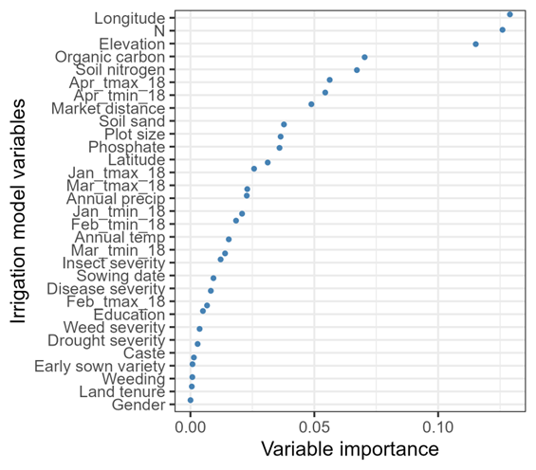

Figure A3: Variable importance plot for irrigation model. Note: The variable importance plot shows the variables that interact with the respective treatment variable.

Figure A4: Variable importance plot for variety model. Note: The variable importance plot shows the variables that interact with the respective treatment variable.

Figure A5: Difference of standardized predictors between highest and lowest quartile of yield gains between S&M herbicide and no weeding

Figure A6: Difference of standardized estimates between highest and lowest quartile of yield gains between early sowing (1-10 Nov) and late sowing (after 16 Dec).

Figure A7: Difference of standardized estimates between highest and lowest quartile of yield gains of four irrigations as compared to one irrigation.

Figure A8: Difference of standardized estimates between highest and lowest quartile of yield gains of SUPER 303 as compared to HD 2967.

Figure A9: Maximal average yield treatment choice for each individual farmer.

Figure A10: Yield predictors (RF)

Figure A7: Depth 2 prioritization without latitude and longitude variables in the specification

1. Note that the approach can also be used for expost analyses. We are referring to it as *exante* because there is no institution sanctioned specific intervention we are investigating. Our targeting exercises are also based on hypothetical policy comparisons. [↑](#footnote-ref-1)
2. Table A1in the appendices shows the descriptive statistics of the rest of the variables. [↑](#footnote-ref-2)
3. A map showing these choices spatially is in Appendix figure A5. [↑](#footnote-ref-3)
4. For simple maximum yield treatment choice, see appendix figure A2. [↑](#footnote-ref-4)
5. We do not show for sowing dates because it is difficult to estimate the monetary cost of the adjustment. For varieties, we do not have seed prices. In the case of weed management, the cheaper alternatives (herbicides) are those giving higher yield gains as such there is no change in the allocation. [↑](#footnote-ref-5)